Title

Author AA ¹,* , Author BB ² , Author CC ³
¹ Example: University of Bonn, Department of Geography, Meckenheimer Allee 166, 53115 Bonn, Germany;
² California State University, 800 State College Blvd, Fullerton, CA 92831, United States;
³ Humboldt University of Berlin, Geography Department, Rudower Chaussee 16, 12489 Berlin, Germany
xxxx.xxx@gmail.com (A.A.); zzzz_zzz@gmail.com (B.B.); yyyy.yyy@yahoo.com (C.C.)
Received: date; Revised: date; Accepted: date; Published online: date
__________________________________________________________________________________________________________________________
ABSTRACT: A single paragraph of about 300 words maximum. For research articles, abstracts should give a pertinent overview of the work. Central European Journal of Geography and Sustainable Development (CEJGSD) introduced the structured abstract for the following reasons. It provides readers and researchers with quicker access to the most relevant articles. It facilitates selection of relevant articles for research, and increases the speed of literature search. This supports the dissemination of the research, and increases the probability that it is read by a wider public. It facilitates the assessment of relevance of the research by the editorial board. By exposing the originality and practical implications, we try to support the social value of research, as it shows its relevance for society. The abstract should contain the following elements: aim, research methods, conclusions, originality / value of the article, implications of the research (if applicable), limitations of the research (if applicable).

KEYWORDS: Word One, Word Two, Word Three, Word Four, Word Five (List five to seven pertinent key words specific to the article, separated by comma).

TO CITE THIS ARTICLE: A, A., & B, B. (2024). Article title. Central European Journal of Geography and Sustainable Development, 6(2), 6–22. DOI: 10.47246/CEJGSD.2024.6.2.X
_________________________________________________________________________________________________________________________
1. INTRODUCTION
The introduction should briefly place the study in a broad context and highlight why it is important. It should define the purpose of the work and its significance. The introduction includes the justification for the topic importance. The introduction section includes the aim/objective. The introduction section includes brief information on methods. The content of each section of the article is briefly described in the last paragraph of the introduction.

2. LITERATURE REVIEW

The purpose of the literature review is to analyze critically a segment of a published body of knowledge through summary, classification, and comparison of prior research studies, reviews of literature, and theoretical articles. Is the literature review properly prepared? Is primary literature correctly summarized? The literature review shows who dealt with similar research topic before? The literature review shows what are the results of the prior studies? Did the Author position himself/herself among the previous researchers? Are different options/perspectives from the literature covered in the reviewed article? The difference with existing studies is explicitly identified and documented. The text includes references whenever necessary.

3. RESEARCH METHODS
This section is compulsory and it should provide specific description of the methodology. The research methodology section includes the description of the material selection. The research methodology section includes: the hypothesis (-es). The research methodology section includes the description of the research methods. The article identifies strengths and weaknesses of the methodology and its findings.

4. RESULTS

This section may provide a concise and precise description of the experimental results, their interpretation as well as the experimental conclusions that can be drawn (Table 1).

Table 1. This is a table. Tables should be placed in the main text near to the first time they are cited
Year Number of foreign tourists Foreign currency Cashing increase
(millions) cashing (USD billions) compared to 1950
1950 25,3 2,1 -
1990 410,4 300,4 143,0
2010 940,0 919,0 437,6
2013 1 087,0 1 159,0 551,9
Source: UNWTO (2017)

This section may provide a concise and precise description of the experimental results, their interpretation as well as the experimental conclusions that can be drawn (Figure 1) or (Figure 1a,b).
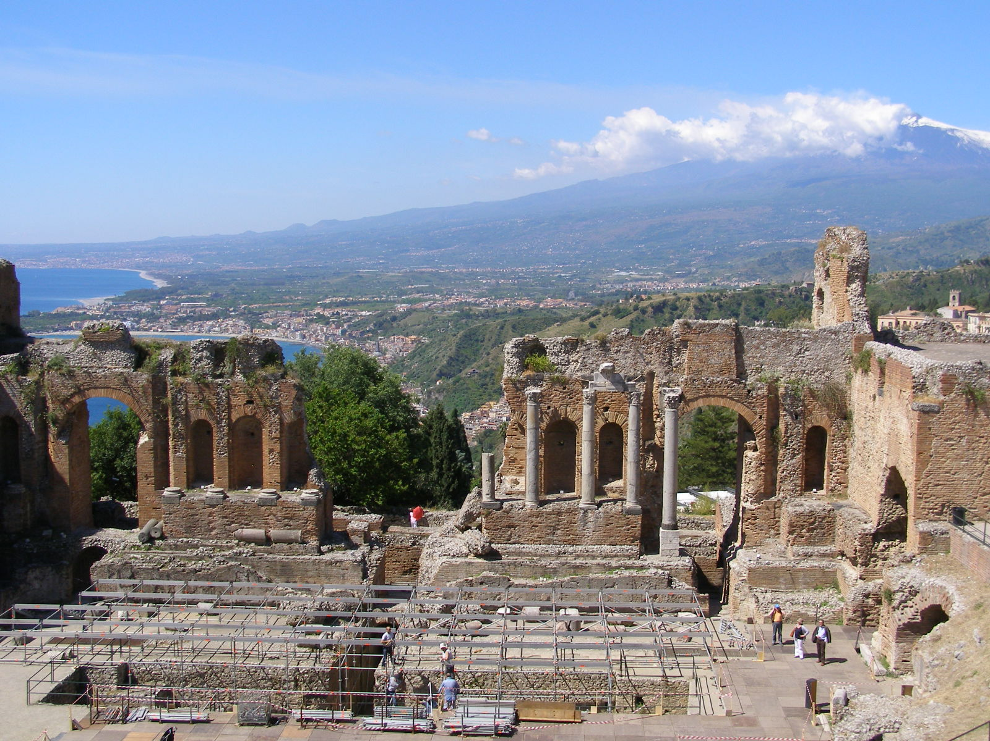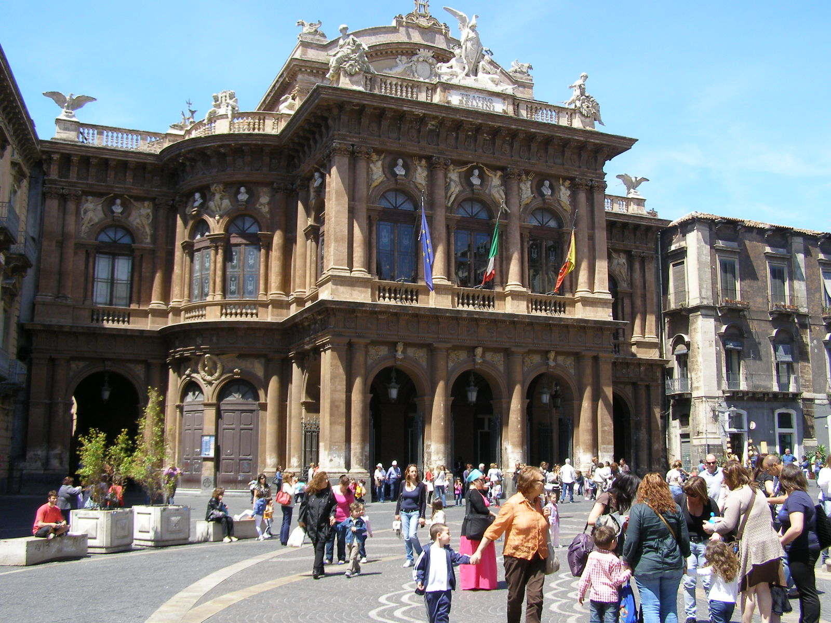
(a) (b)
Figure 1. This is a figure. Schemes follow the same formatting. If there are multiple panels, they should be listed as: (a) Description of what is contained in the first panel; (b) Description of what is contained in the second panel. Figures should be placed in the main text near to the first time they are cited. A caption on a single line should be centered.
Source: Adrian Nedelcu (2014)
Are the results discussed in details? Is the research problem original and a kind of novelty? Has the Author given the appropriate interpretation of the data and references? Are the pieces of information used inside the paper comes from reliable sources?

4.1. Subsection

Subsection subsection subsection subsection subsection subsection subsection subsection subsection subsection subsection subsection subsection subsection. Subsection subsection subsection subsection subsection subsection subsection subsection subsection subsection.

4.1.1. Subsubsection

Subsubsection subsubsection subsubsection subsubsection subsubsection subsubsection subsubsection subsubsection. Subsubsection subsubsection subsubsection subsubsection subsubsection subsubsection subsubsection subsubsection subsubsection.

Subsubsubsection

Subsubsubsection Subsubsubsection Subsubsubsection Subsubsubsection Subsubsubsection Subsubsubsection Subsubsubsection Subsubsubsection. Subsubsubsection Subsubsubsection Subsubsubsection Subsubsubsection Subsubsubsection Subsubsubsection Subsubsubsection.

5. DISCUSSION
Authors should discuss the results and how they can be interpreted in perspective of previous studies and of the working hypotheses. Future research directions may also be highlighted.
The checklist: The article assesses and critiques the findings and/or the statistical analysis. Are the findings in the article compared to findings of other authors?

6. CONCLUSIONS
This section should contain the results of the research and some future research plans. The checklist: Does this part include the general summary of the article, its results and findings? Does this part include implications and recommendations for practice? Does this part include research limitations? Does this part include suggestions for future research?

ACKNOWLEDGMENT (Optional)

Any acknowledgment to fellow researchers or funding grants should be placed within this section. All institutions and persons who supported the respective author/s research should be mentioned. This should be placed before bibliography, and must be written in third person.
USE OF AI TOOLS DECLARATION
An example: The authors declare they have not used Artificial Intelligence (AI) tools in the creation of this article.
AUTHOR CONTRIBUTIONS
An example: All authors contributed equally to this work. All authors read and approved the final manuscript.
CONFLICTS OF INTEREST
An example: The authors declare no conflict of interest.

REFERENCES
Citations in the text and the list of references should follow the referencing style used by the American Psychological Association, the latest version of the APA Publication Manual (i.e., APA 7), which released in October 2019. Some examples of references in APA (American Psychological Association) style are included in the Guidelines for Authors section; it is highly recommended that you reference an actual APA style manual (7th edition).
Details concerning this referencing style can be found at http://www.library.cornell.edu/resrch/citmanage/apa
Some examples of references in APA style (7th edition) are included below.
Book with one author:
Fennell, D. (2008). Ecotourism. Third edition. Routledge.
Book with two authors:
Jones, R., & Shaw, B.J. (2007). Geographies of Australian Heritages: Loving a Sunburnt Country? (1st ed.). Routledge. https://doi.org/10.4324/9781351157520
Book with more than two authors:
Carter, T., Harvey, D., Jones, R., & Robertson, I. (Eds.). (2019). Creating Heritage: Unrecognised Pasts and Rejected Futures. Routledge. https://doi.org/10.4324/9781351168526
Journal article with DOI:
Leimgruber, W. (2021). Tourism in Switzerland – How can the future be? Research in Globalization, 3, 100058. https://doi.org/10.1016/j.resglo.2021.100058
Journal article without DOI (when DOI is not available):
Murray, I., Rullán, O., & Blázquez, M. (2005). Las huellas territoriales de deterioro ecológico. El trasfondo oculto de la explosión turística en Baleares. Scripta Nova, IX(199). http://www.ub.es/geocrit/sn/sn-199.htm
Article in a magazine or newspaper:
Benabent Fernández de Córdoba, M., & Mata Olmo, R. (2007, July 13). El futuro de la geografía. El País. https://elpais.com/diario/2007/07/13/opinion/1184277607_850215.html
Edited book:
Yang, P. (Ed.) 2018. Cases on Green Energy and Sustainable Development. IGI Global.
Chapter in an edited book:
Privitera, D., Štetić, S., Baran, T., & Nedelcu, A. (2019). Food, Rural Heritage, and Tourism in the Local Economy: Case Studies in Serbia, Romania, Italy, and Turkey. In J. V. Andrei, J. Subic, A. Grubor & D. Privitera (Eds.), Handbook of Research on Agricultural Policy, Rural Development, and Entrepreneurship in Contemporary Economies (pp.189-219). IGI Global. DOI: 10.4018/978-1-5225-9837-4.ch010
Conference proceedings (published):
García Palomares, J. C., Gutiérrez Puebla, J., Romanillos Arroyo, G., & Salas-Olmedo, H. (2016). Patrones espaciales de concentración de turistas en Madrid a partir de datos geolocalizados de redes sociales: Panoramio y Twitter. In Aplicaciones de las Tecnologías de la Información Geográfica (TIG) para el desarrollo económico sostenible (pp. 131-139). Actas del XVII Congreso Nacional de Tecnologías de Información Geográfica. Málaga, June 29-30 and July 1. http://congresotig2016.uma.es/downloads/separadas/lt1/García%20Palomares.pdf
Working paper (more than twenty authors):
De Stefano, L., Urquijo Reguera, J., Acácio, V., Andreu, J., Assimacopolus, D., Bifulco, C., De Carli, A., De Paoli, L., Dias, S., Gad, F., Haro Monteagudo, D., Kampragou, E., Keller, C., Lekkas, D., Manoli, E., Massarutto, A., Miguel Ayala, L., Musolino, D., Paredes Arquiola, J., … Wolters, W. (2012). Policy and drought responses–Case Study scale (Technical report no. 4). DROUGHT-R&SPI project. http://www.isa.ulisboa.pt/ceabn/uploads/docs/projectos/drought/DROUGHT_TR_4.pdf
Webpage or piece of online content:
Vasile Loghin – Geographical Works. Volcano Island. Geological, geomorphological and volcanological features.
https://vasileloghin.files.wordpress.com/2015/02/insula-vulcano-cu-foto-final.pdf

Facebook page:
American Association of Geographers - Home [Facebook page]. Facebook. Retrieved September 19, 2022 from
https://www.facebook.com/geographers

Non‐English references should contain, at the end, additional explanation in which language it was written. If the article contains English summary it should be mentioned. For example:
Grahovac, M., Pivac, T. & Nedelcu, A. (2018). Značaj internet prezentacije za razvoj vinskog turizma Banata(Srpski i Rumunski Banat), SINTEZA 2017, International Scientific Conference on Information Technology and Data Related Research. (in Serbian with English abstract & summary)
Dinu, M. (2002). Geografia turismului [Tourism geography], Editura Didactică și Pedagogică. (in Romanian)

Appendix I. Title of the appendix

The text of the appendix will start here. Remove this section in case it is not needed.

© 2024 by the author(s). This article is an open access article distributed under the terms and conditions of the Creative Commons Attribution-NonComercial (CC-BY-NC) license (http://creativecommons.org/licenses/by/4.0/).

* Corresponding author: mail@gmail.com; Tel.: +xx-xxx-xxx-xxxx

